Name _______________________
Chemistry: The Relationship between Pressure and Volume – Boyle’s Law
Mr. Graham
March, 2007

Warm-Up: A different look at pressure……Pressure and the Guillotine

Pressure is mathematically defined using the following formula:

Pressure = force / area

Looking at the guillotine below and explain the shape of the blade as a successful method of decapitation.

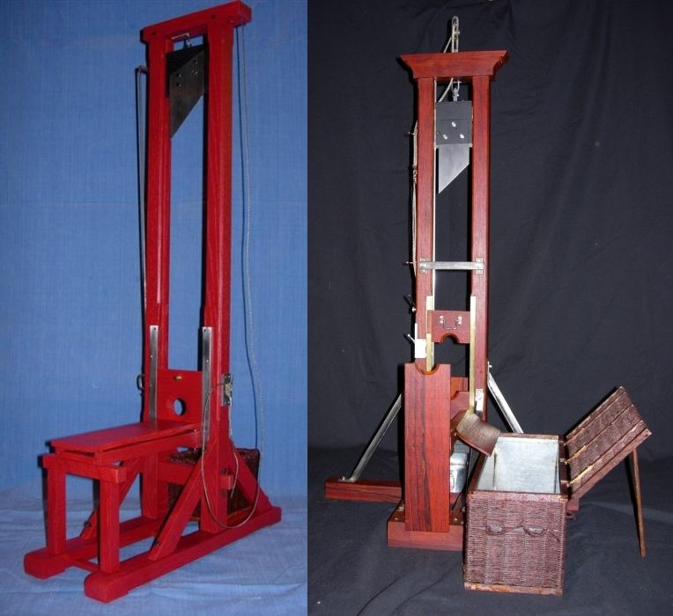

Objective: To look at the relationship between the volume of a container and the pressure of the gas in the container.

- Cover the hole at the syringe’s end with your finger. What happens to the pressure of the air inside the syringe when you push the plunger down?

2. …………..when you pull the plunger up?

- Put a marshmallow in the syringe and replace the plunger. What happens to the volume of the marshmallow as you push the plunger down (and increase pressure of the air inside the syringe)?

- What happens to the volume of the marshmallow as you pull the plunger up (and decrease the pressure of the air inside the syringe)?

- What type of relationship (direct, inverse) exists between the volume a gas takes up in a container and its pressure?

Back to the simulation program….you will investigate the mathematical and graphical relationship between the volume of a container and the pressure of the gas in the container.

Fill the container with 150 molecules of the heavy gas (carbon dioxide?).
Have temperature be your constant parameter!!!

Length of container (to the nearest tenth of a nm) | Height of container (to the nearest tenth of a nm)  (Layer tool in measurement tools) | Width (to the nearest tenth of a nm) | Volume (to the nearest tenth of a nm ³) | Pressure (to the nearest tenth of an atm) | Pressure x volume (round to two sig figs)
 |  | 4.0
 |  | 4.0
 |  | 4.0
 |  | 4.0
 |  | 4.0

What relationship exists between the volume of the container and the pressure of the gas?

What do you notice about the product of pressure and volume?

Can you write an equation for the above question?

Make a quick graph of pressure (on the y-axis) as a function of the volume (x-axis) below.

Will the relationship between volume and pressure be the same for a light gas (helium?)? Try it!

Homework: Read Section 12.2 + Problems 17, 21, 23 on page 390.

