Learning Goals: Students will be able to:
- Use a physical experiment to model chemical equilibrium
- Sketch how the number of reactants and products will change as a reaction proceeds
- Predict how changing the initial conditions will affect the equilibrium amounts of reactants and products.
- Predict how the shape of the reaction coordinate will affect the equilibrium amounts of reactants and products.

PART 1: Done in pairs in class

Materials: 4 beakers: 100 mL and 50 mL and two 1000 mL beakers,

Directions: Read a-e, make an appropriate data table, and then begin.

- Label the 1000 ml beakers A and B
- Put about 700 ml water in the large beaker “A”. Leave the other beaker “B” empty.
- Record the volume of water in the beakers in your table.
- Transfer water between the large beakers using the following “rules”
- Use the 100 mL beaker to transfer water from A to B;
- Use the 50 mL beaker transfer water from B to A.
- Fill the small beakers as full as possible without tipping the large beakers in any way.
- One cycle consists of one A → B transfer and one B → A transfer.
- For each cycle, record the volume of water in beakers A and B.
- Continue cycles and recording the volumes, until the level of water in beakers A and B are unchanging.

Analysis:
- Graph the volumes of water in beakers A and B per cycle.

- Describe in your own words how this experiment relates to chemical reaction equilibrium.

- What is the ratio of the volume in Beaker B to Beaker A at equilibrium? _____When we work with chemical experiments, what do we calculate that is similar?

- What do you think would be different and same if the water transfers were repeated with the beaker A initially half full?

- Repeat the directions to test your ideas. Use a table, graph, and ratio of B to A to show your results. Explain how your ideas were supported or need to be corrected.

- Sketch what you think the graph will look like if you repeated the directions starting with beaker A empty and beaker B with 700ml? Remember that a “cycle” is using the 100ml beaker to take from A and the 50ml beaker to take from B.

- Repeat the directions to test your ideas. Use a table, graph, and ratio of B to A to show your results. Explain how your ideas were supported or need to be corrected.

- If you wanted to optimize the final ratio of B volume to A volume, without changing the cycle definition “using the 100ml beaker to take from A and the 50ml beaker to take from B” how might you change the experimental design?

PART B: Done for homework; may be done with your partner from PART A
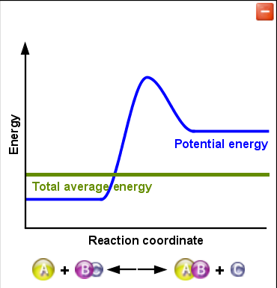
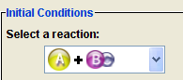
Figure A
- Open Reaction and Rates, using the Rate Experiments tab, design experiments and provide evidence to answer the following. Use the default reaction as shown in Figure A.

- With the water exchange experiment, Beaker A water represented reactants and Beaker B represented the products; how does this chemical reaction sim compare?
- How do you know when equilibrium has been reached?
- How does changing the initial amounts of the reactants affect the amount of product?
- How does changing the initial temperature of the reactants affect the amount of product?

- Each team will be assigned one of the other reactions to test. Be prepared to share your results with the class.

