Purpose – The purpose of the energy skate park simulation is to see how energy gets transferred in a real world application. In this simulation you will manipulate the skater, friction, gravity, and other factors to see the affect of these on a skater who behaves according to the laws of physics.

Energy Transfer without Friction – Make a prediction 1st!

You have already learned that in a frictionless, or air resistance less world, that potential and kinetic energy are readily exchanged in a mechanical system and total energy is conserved. For each graph below, draw the expected potential, kinetic, and total energy of a skater going down a curved track, then back up the other side, with no friction. Show multiple (at least 3 cycles)

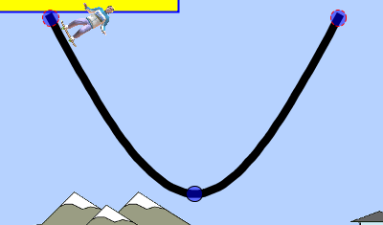

PE
KE
TE

With Friction – Now in an environment with friction, some of the energy is lost as heat. For each graph below, draw the expected potential, kinetic, and total energy of a skater going down a curved track then back up the curved track, with some small amount of friction. Show multiple (at least 3 cycles). In addition there is a graph of total heat (not instantaneous heat). Make a prediction of what a graph of this would look like too.

PE
KE
TE
Heat
SIMULUATION TIME –

Now go back and simulate the motion both without (top set of graphs) and with friction (bottom set of graphs), and mark on the graph the actual energy as measured in the simulation. Even if you got it right, go back and mark (in another color) the actual shape.

Affect of gravity

On the graphs below, show the difference you might expect if you put the skater on Jupiter, where gravity is approximately 2.65x that of Earth. Label the graphs in terms of the PE, KE, and TE of the Earth graphs above. Remove Friction again!

PE
KE
TE
Heat
SIMULATION TIME –

Now go back and simulate the motion as if on Jupiter, and without friction, and mark on the graph the actual energy as measured in the simulation. Even if you got it right, go back and mark (in another color) the actual shape. What would the graph of heat look like?

Affect of Gravity Part II – Now you are going to speculate as to what happens if there is no gravity. Or more importantly, how to simulate gravity when there is none. Set the skater on the end of the track with the gravity of “Space” selected. You will note that he does not move. If you use the arrow keys you can get the skater to move. If you push the down arrow the skater will go down. But the fire from the rocket is going up. Which of Newton’s laws ensures this is what happens?

Affect of Gravity Part II continued – You have been told that weight is nothing more than a force, but that it is impossible to distinguish this from an accelerating frame of reference. If you accelerate the skater down, does he behave exactly the same as he does in a gravitational field? Try it, and explain what you observer. Why do you think the simulation behaves this way?

The writers of this software show that PE is zero in space (far from anywhere). Does this make any sense, why is it not infinite (mg * h = mg*∞)? Hint: They are correct on this one, what does gravitational potential mean really?

JFF – Just for fun

- See if you can have the skater do two loops
- See if you can have the skater go airborne, but land on another track
- See if you can have the skater say cow-a-bunga.

