Name __________________________ Teacher__________ Per ____ Date_________________
Estimating the Length of Everyday Objects
Learning Goals: Students will be able to estimate the size of ordinary classroom objects in inches, feet, centimeters, and meters. They will also be able to calculate accuracy.

- Without actually measuring it, estimate (guess) how long you think each object is. Fill in ONLY the COLUMN labeled “I think it is…!
Object | I think it is …. | Measured value (Do this later! during part 10) | Accuracy  (Do this later! during part 10)
Length of this paper | ______ cm  ______ inches
Width of this paper | ______ cm  ______ inches
Your height | _____ meters  _____ feet
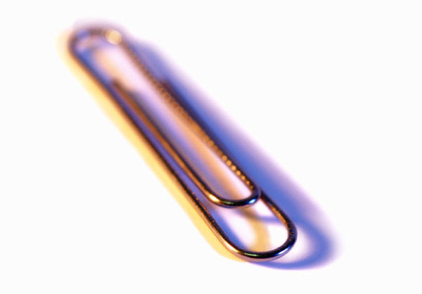  The length of a paper clip | ______ cm  ______ inches
The length of the whiteboard | _____ meters  _____ feet
The height of the whiteboard | _____ meters  _____ feet

- Play with the PhET Estimation simulation (http://www.colorado.edu/physics/phet/web-pages/simulations-base.html. Click on “Math Tools” in the left column, then “Estimation”)
Start time | End time | Accuracy

  - Look at the clock. Write down what time you start.
  - Click on the “Play” button and start at Level 1.
  - Watch the clock, and stop after 10 minutes.
  - Write down your accuracy score.

- Suppose your friend is not very good at this estimating game. What advice would you give to help your friend get better?

- Using your ruler, draw an ant that is 1 cm long here:

- Using your ruler, draw a spider that is 1 in long here:

- This pencil looks like the one left in my room at the end of class yesterday:

  - WITHOUT using a ruler, estimate how long the pencil is in cm, then in inches. Write your estimate in the table below.
  - Now measure the pencil. Write your measurements in the table.
  - Finish filling in the table by calculating the accuracy. Find the accuracy by using this equation. Show your calculation in the table.
Accuracy = (Measurement – estimate) ÷ measurement × 100
Estimate: | Measurement: | Show how you calculate accuracy: | Accuracy:
_____ cm | _____ cm |  | %
_____ inches | _____ inches |  | %

- How long is the cell phone? Fill in the table: estimate, measure, calculate accuracy.
Estimate: | Measurement: | Accuracy
______ cm | ______ cm | %
______ inches | ______ inches | %

- What is something in the room that you could estimate the size of that would be close to a few feet or a few meters? ______________Draw a picture of this object. Then complete the table.

Picture: | Estimate: | Measurement: | Accuracy
 | ______ cm | ______ cm | %
 | ______ inches | ______ inches | %

- On the table on the first page:
- Change your estimate if you need to. Put a neat line through the original answer.
- Measure the objects.
- Calculate the accuracy.

