Name __________________________ Teacher_______ Per_____ Date___________________
Motion Graphs Warm-Up

A policeman is tracking the motion of cars near a stoplight. His radar detector recorded their motion in these graphs, and he needs your help interpreting the graphs. Tell him how the car was moving. The stoplight is at position 0 meters.
Motion graphs | Description of car’s motion:
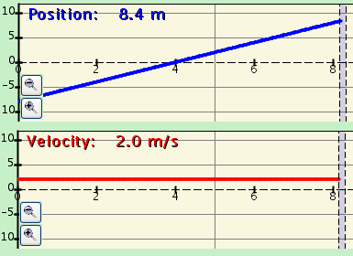
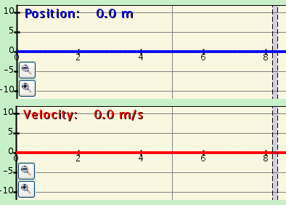

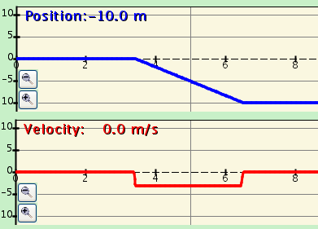
time
time
time
time
time
time

Car #1

Car #2

Car #3

The policeman also watched a truck that was sitting at the red light. When the light turned green, the truck slowly started moving, getting faster and faster until it was going a constant velocity. What do you think the motion graphs looked like? Explain why you think they look this way.
Position-time | Velocity-time | Why do you think they will look like this?

What is the pedal called that the truck driver pushes on to go faster and faster?_____________________

