Name ______________________________ Teacher______________ Per_____ Date_______________________
Pre/Post Questions for Motion Graphs

- Below is a graph of a ball’s motion. Which of the following describes ball’s motion?
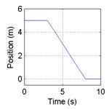
- The ball moves along a flat surface. Then it moves forward down a hill, and then finally stops.
- The ball doesn’t move at first. Then it moves forward down a hill and finally stops.
- The ball is moving at constant velocity. Then it slows down and stops.
- The ball doesn’t move at first. Then it moves backwards and then finally stops.
- The ball moves along a flat area, moves backwards down a hill and then it keeps moving.

- Which graph would best match the following story? A man walks backwards slowly and steadily for 6 seconds. Then he stands still for 6 seconds, then walks forward steadily about twice as fast for 6 seconds. Note that these are velocity-time graphs.

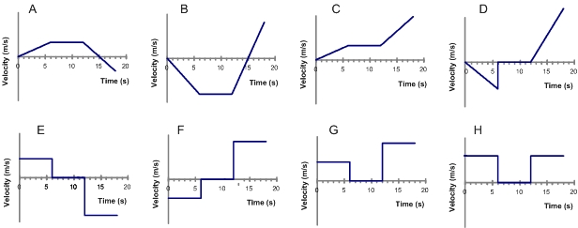
- For the same story as # 2, which position-time graph best matches the motion?
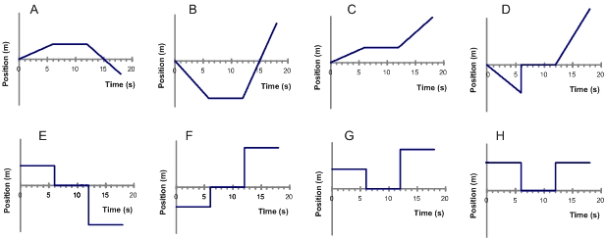

- A car is traveling along a road. Its velocity is shown in the graph below.
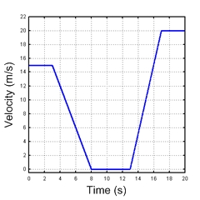
When is the car accelerating? Choose all the answers that apply.
  - between 0 and 3 seconds
  - for a brief instant at 3,8,13 and 17 seconds
  - between 3 and 8 seconds
  - between 8 and 13 seconds
  - between 13 and 17 seconds
  - between 17 and 20 seconds

5. Which of these position-time graphs matches the motion of the car in question #4? Note that these are position-time graphs, and #2 was a velocity-time graph.
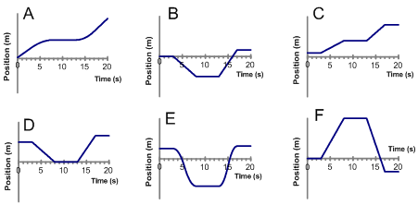

6. A car is moving forward and applying the brake. Which velocity-time graph best shows this motion?
