Properties of Electric Circuits

Procedures: Go to www.colorado.edu/physics/phet and open the Circuit Construction Kit (CCK).

I. Batteries
Label three real batteries 1, 2, and 3 with masking tape. Measure the voltage of each one separately and record the real voltage in a table like the one shown. Then hold the batteries end to end as below to measure voltage for combinations. Using CCK, do the same procedure and record the results in the third column.
1
2
3
1
2
Battery | Voltage (V) Real | Voltage (V) Simulation
1
2
3
1+2
1+2+3

1+2 1+2+3

- Describe the relationship between the number of batteries and the voltage and explain what you think might be physically happening.
- How does the real world data differ from the simulation? Explain what might cause the differences.
- What do you see as the benefits of using the simulation?
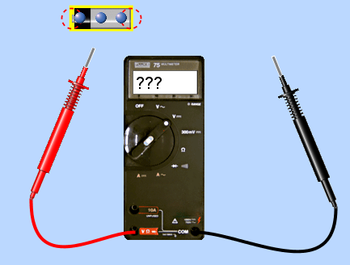
II. A Useful Circuit (Simulation Only)
Use the CCK sim to build a circuit with a battery and a light bulb in the Lifelike visual mode.
- Draw what your circuit looks like.
- Describe what is happening in real-world terms; explain why the circuit does what it does. What are the blue dots?
- How does the voltage of the battery compare to the light bulb voltage? Explain what you think is happening.
- Predict what will happen to the light when you increase the voltage, then vary the voltage of the battery (by right-clicking on it) and write down your observations. Thinking about a real light bulb and battery, explain what you think is physically happening that causes this.
- Try changing the voltage of the battery and describe what happens to the speed of the “blue dots.”
- If you had a battery, a light bulb, and only one bendable wire, sketch how you would light the bulb.

III. A Short Circuit (Simulation Only)
In the CCK sim, connect two wires to a battery and join them all to form a simple circuit.
- Why do you think the battery is on fire? What would happen if you tried this with a real battery and wire?
- What is the voltage across the battery now? Explain the cause of the difference between now and in part I.
- Use the voltmeter to measure voltage across various sections of the wires and batteries. Sketch your circuit, and mark the voltages you found. Where do you find the highest voltage?
- What does an ammeter measure? Add an ammeter to your circuit and give the number of amps.

IV. Ohm’s Law: V=IR (Simulation Only)
Create a circuit in CCK that includes a 9V battery and a single resistor. Place an ammeter in the circuit to read current.
- Use Ohm’s Law to calculate the resistance in the circuit.
- Now right-click on the resister and select “Show value.” What is the sim’s value for the resistance of the resistor? Compare with the value you found. What is the cause of the discrepancy?
- Keeping the voltage the same, change the resistance of the resistor to 9 other values by right-clicking on it. Record resistance and current in a data table, and graph your findings in Excel. Explain how current varies with resistance, for a battery of the same voltage.
- Click on “Advanced” and alter the resistivity of the wires. Describe what happens to your circuit.

V. Conductors and Insulators (Simulation Only)
Create a circuit in CCK that includes the items listed below, which are found in the Grab Bag.
- The hand: At what voltage does the human body carry a current that begins to measure on the ammeter? (Right-click on the battery to change the voltage, and check the “More voltage” box to get even MORE voltage if necessary.)
- Given the voltage and current you found in part (a), what is the resistance of the human hand? What might happen to this resistance if your hand were wet?
- Experiment with the other items in the grab bag and explain your results. Compare the resistivity of the good insulators with the good conductors.

