Homework Activity 1

Course: Physical Science for future Elementary and Middle School Teachers

Learning Goal: To help students visualize the flow of electrical charge in a series-parallel combination circuit.

Simulation(s) used: Circuit Construction Kit

Type of Activity: Homework

Set-up: Set-up a series-parallel circuit similar to what we have below.
2
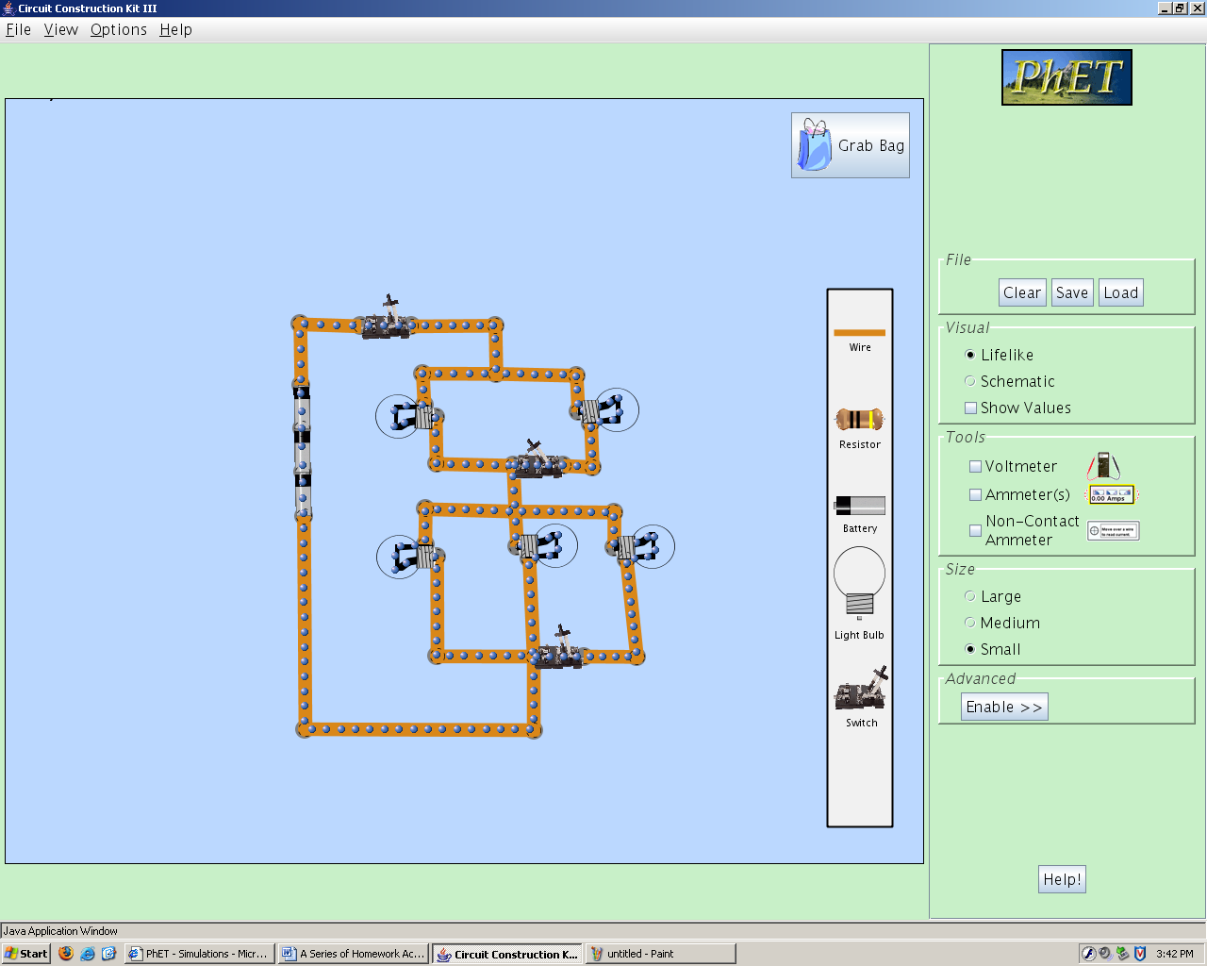

Activity Development:
- Construct in PhET Sims the circuit drawn above.
- Document your observations as you explore each of the following variations:
  - Case 1: Describe the brightness of each of the bulbs when switch 1 is open, switches 2, and 3 are closed.

  - Case 2: Describe the brightness of each of the bulbs when all the switches are closed.

  - Case 3: Describe the brightness of each of the bulbs when switches 1, and 2 are closed but switch 3 is open.

  - Compare the brightness of bulb A in cases 2 and 3 above. Explain your observations.

