Learning Goals: Students will be able to
- Determine the variables that affect how charged bodies interact
- Predict how charged bodies will interact
- Describe the strength and direction of the electric field around a charged body.
- Use free-body diagrams and vector addition to help explain the interactions.

Background:
We will have briefly studied gravity last semester. We drew force diagrams to explain motion, but the concept of field as a vector is not developed. We will have studied magnets and done some qualitative investigations addressing magnetic fields. The students will have had several opportunities to add vectors, but it has been a few months.
I will do some traditional static electricity demonstrations and use the lesson plan that uses Balloons and Static Electricity and John Travoltage. (I have the demonstrations posted on the PhET educational resources) I have a couple of balloons that I can readily charge. We will discuss how the mass of the balloons could be varied. (Put sand in them perhaps). Also I use two scotch tape strips; I stick them to the table and then rip off, the pieces repel well and you can reverse one so they attract. I’ll use my demonstration electroscope to help them how charge might be measured, but mine is very gross. I have a large glass and plastic rod to rub on some pieces of clothing to use on the electroscope.

Electric Field Hockey Introduction: Talk about an air hockey table and mention that this sim is like looking down on one. Instead of hitting the puck, this sim makes it move by using charged bodies like the charged balloons. I want to have them use the Practice mode for testing their ideas about how charge affects motion. Show them the difference between Clear (everything is zeroed) and Reset (the puck is brought back to starting point with same charges).
I think having the Trace tool on is helpful. Point to the Puck is Positive option. The Antialias feature is just a programming tool; if you turn it on the resolution is better, but the program runs more slowly (less realistic). Demonstrate how using multiple charges can be used to make a goal.
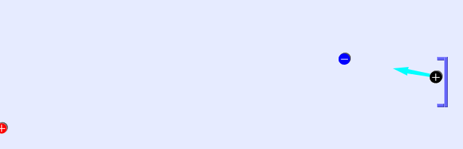Goal!!

Just a note: Static electricity and inertia is affecting the puck.

Charges and Fields Introduction:
It’s important to realize that once you place a charge, it is fixed. The E Field sensors are like the like the puck from the Field Hockey, but it measures like the electroscope rather than responding with motion. I would recommend leaving the resolution (Show lo res and Show hi res) off for those most part to speed up investigations.

Lesson:
Go over the following problems:
- Draw the free body diagram for a file cabinet being pushed by a person.
- If the file cabinet is being pushed with 30 N and the friction force is 20, what is the net force?
- Find the resultant force if the cabinet is being pushed with 20 N north and 30 N east, assuming there is no friction.
- How does the resultant change if we do consider the friction?

Then, have the students use the lab sheet for guidance. The activity should take my honors physics students about 80 minutes.

Post lesson: use the clicker questions and perhaps discuss these questions from Perkins’ homework for a PHYS1010 lecture on electric charges from CU Boulder. The CU assignment can be downloaded from the PhET Teaching Ideas pages.

“ We can use the electric field hockey game to help us think about electrostatic forces that are occurring in our everyday lives. Which one of the above charge distributions would be a helpful guide in thinking about the electrostatic forces in the following scenarios?
a charged balloon (puck) sticking to the wall: C
A negatively charged balloon sticks to the wall because the wall's negative charges are farther away than the wall's positive charges, making for a net attraction.
a charged sock (puck) sticking to a shirt: D
The negatively charged sock is attracted to the shirt because of the shirt's positive charge.
a charged dust particle (puck) in an air cleaner: A
In an air cleaner, the charged dust particles move between one negatively charged plate and one positively charged plate.

