I have divided the learning goals into two activities.

1 Wave Representation Learning Goals:
Students will be able to think about waves as a function of time, space or space-time and explain why waves might be represented in these different ways.

2 Superposition of Waves Learning Goals:
Students will be able to:
- Define harmonic, determine the relationship between the harmonics,
- Explain the relationship between harmonics and the corresponding wave function.
- Predict what happens when more than one wave is present. I want the students to be able to superpose waves to find the sum.

Background:
We will have added several types of vectors. They do the Waves on a String activity before these activities. We did the three activities on two 50 minute days and one 90 minute day, along with some lecture and homework review.

Fourier-Making Waves Introduction:
I didn’t need to show my students anything, but I made a list of some hints to remember. You can change the amplitude by grabbing the bar or typing in a number in the box. As soon as you do, the function changes to custom. Also, show how to set the SUM window on Auto scale. It only auto scales the y axis and reflect axes scales. When you reset, the scale returns to default. The Sum Graph is the observable disturbance.

Lesson:
The students will need their papers from the Waves on a String activity. Have the students use the lab sheet for guidance.

Things I want to remember when I designed the activities:
Activity 1:
1. When you change function from space to time. There are no changes other than the axis label and period tool now available rather than wavelength.

Activity 2:
- Harmonics have same amplitude but wave lengths that get smaller. To calculate the wavelength of n harmonic divide the wavelength of the fundamental wave (n=1), by the n of the harmonic. In our physics books, the fundamental frequency is given value of n=0 so the equation is not in this form, but I expect this is the form that students will derive. We will have to reconcile with the books convention, but I’ll do this later.
- I would want them to see that the SUM window looks like the name and that the individual waves add to give that shape, more harmonics make the sum curve smoother. I am not concerned that they discover the sum part yet.

- The amplitudes were 1 and .35. The sum looks like this. The x axis labels have changed.
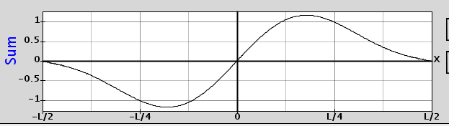

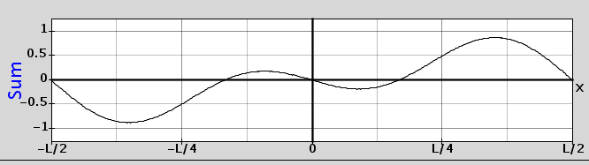
- The amplitudes were .5 and -.5 for amplitudes. The sum looks like this.

- The amplitudes were .5 and 1. I had to use Auto scale to see the whole graph.
