Background – Graphs are a way of communicating by using pictures, and since a picture is worth a thousand words, knowing how to make and interpret graphs will save you a lot of writing!

Lab Write-up – Title, Procedures, Data (i.e. all of your graphs, with explanations, predictions in one color and correct graph in another), and answers to questions 6 – 8.

Learning Goals – The students will be able to accurately interpret and draw position and velocity graphs for common situations and explain their reasoning.

Procedure – Go to http://www.colorado.edu/physics/phet and find “The Moving Man” simulation under the category of “motion.”

1. After “The Moving Man” is open leave the position graph and the velocity graph open but close the acceleration graph by clicking the symbol in the upper righthand corner of the graph.
Investigate Moving Man by dragging the dude around with your mouse. This will give you very jumpy data, especially in the acceleration graph – why? Now try making the man move using the slider arrows. Use the playback features to look at the graphs. While you make observations, discuss in your group the reasons the graphs look the way they do.

2. Making predictions: on your paper, sketch six of the following graphs. Label them A – F. For each of the six scenarios below, in one color, PREDICT what the distance vs. time and velocity vs. time will look like. Don’t be afraid to be wrong – and don’t cheat by looking at Moving Man first! Leave some space for explanations beside or below each graph.
-5
-10
5
0
10
Distance (m)
Time
(s)
-5
-10
5
0
10
Velocity (m/s)
Time
(s)

Explain your reasoning for the appearance of the graphs:

A) A man moving from the center of the screen (0 m) to the house (8m)
at a slow, steady pace.
B) A man moving from 0 to the house at a faster pace than above.
C) A man standing still at 4 m.
D) A man moving from 0 to the house at a fast pace then moving back to 0 at a slower pace.
E) A man moving from 8 m to the tree m at a fast pace.
F) A man moving from 0 to the house, speeding up as he walks.

3. Use the Moving Man simulation to verify or correct your predicted graphs with a different colored pen.

4. In the space below or beside each graph, explain why the distance and velocity graphs appear the way they do.

5. Make new distance vs. time and velocity vs. time charts for each of the following scenarios. Predict what you think the graphs will look like, and then use Moving man to verify or correct your predicted graphs and reasoning with a different color pen.

G) The man stands still while he talks on his cell phone at the middle of the sidewalk, then walks toward the house at a constant rate trying to get better cell reception. He comes to a sudden stop when the coverage is good (about a meter before the house) and stands still to finish his conversation.
H) The man starts close to the tree, stands still for a little while, then walks toward the house at a constant rate for a while, then slows gradually to a stop.
I) A man wakes up from his nap under the tree and speeds up toward the house. He stops because he is worried that he dropped his keys. He stands still as he searches his pockets for his keys. Once he finds them, he continues calmly to walk toward the house and then slows to a stop as he nears the door.
J) The man starts three meters from the house and speeds up as he walks towards the tree.

6. Look at your graphs, reasonings, and the corrections from questions 2 – 5. Discuss (with your group, and then write down your discussion) why some of your predictions were wrong and how your ideas about motion have changed.

7. With your lab partners, write a motion scenario that you could test. Test it, and then write a description of how you used the program to generate the graphs. Sketch the graphs.

8. Individually write a possible scenario for the following graph. Then compare your scenario with your lab partners to check if it is reasonable.

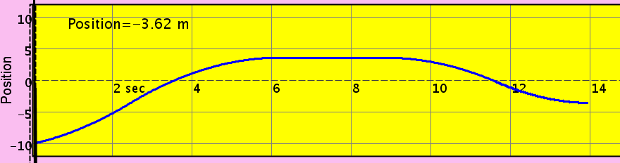 time

