Teacher Pages
Prior Knowledge – The students should know:
- How to make a line graph
- The basic unit of measure for distance is the meter and for speed it is meters per second.
- What is meant by the term “slope of a line”.
Activity & Simulation Instructions-
- This assignment is intended as an assignment the students will complete outside of class either at home or in a library.
- That the 0m point where the moving man is located is an arbitrary point and all distance measurements will be made from that point.
- That the positive and negative values on the position graph represent the direction the man moves from the 0m point.
- To close the acceleration graphs the students need to click on this symbol, located in the upper right hand corner of the acceleration graph
- Give the students a descriptive vocabulary to use in their description of a graph. For example;
Description of | Samples of descriptive phrases
Direction | Moving from ____ to ___ | Moving away from observer | Moving towards observer
Speed | Standing still | Moving slow | Moving fast
Learning Goals – The students will:
- Develop a general knowledge of “Velocity vs. Time” graphs and “Distance vs. Time” graphs
  - What graphs of a person standing still would look like
  - What graphs of a person moving away from an observer at a constant speed would look like.
  - What graphs of a person moving towards an observer at a constant speed would look like.
  - How differences in speed appear on the graphs

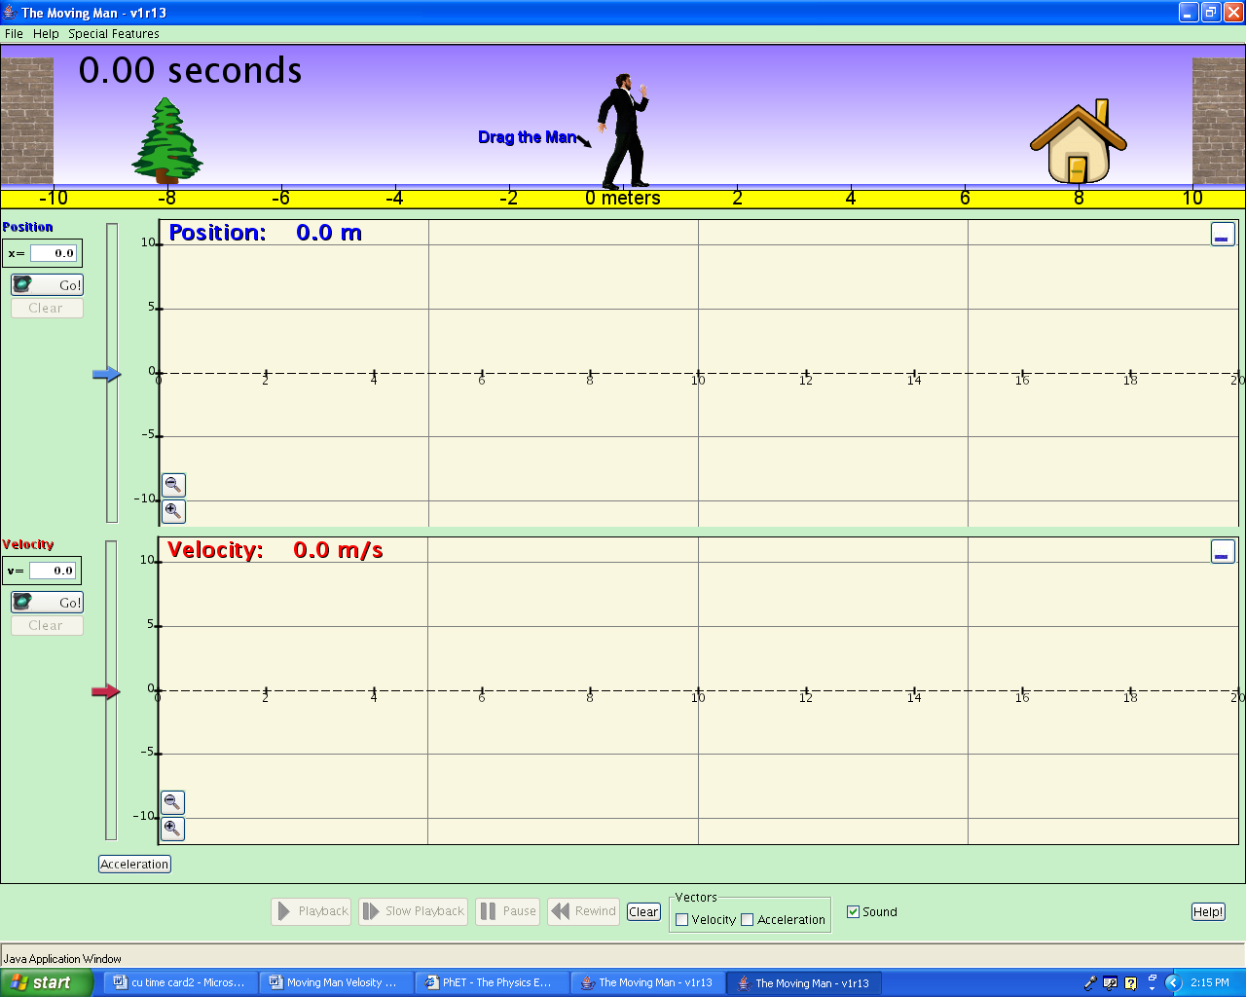
Student Pages
Background – Remember graphs are not just an evil thing your teacher makes you create, they are a means of communication. Graphs are a way of communicating by using pictures and since a picture is worth a thousand words knowing how to make and interpret graphs will save you a lot of writing.
Learning Goals – The students will:
- Develop a general knowledge of “Velocity vs. Time” graphs and “Distance vs. Time” graphs
Screen 1
  - What graphs of a person standing still would look like
  - What graphs of a person moving away from an observer at a constant speed would look like.
  - What graphs of a person moving towards an observer at a constant speed would look like.
  - How differences in speed appear on the graphs

Procedure – Do the following activity using this web site
http://www.colorado.edu/physics/phet/simulations-base.html
Then click on “The Moving Man”

- Getting started. After “The Moving Man” is open leave the position graph and the velocity graph open but close the acceleration graph. Your screen should look like screen 1.
- Making observations. By either clicking on the man or the slider cause the man to move back and forth and observe what shows up on the graphs. Using the axis provided below make sketches of Distance vs. Time and Velocity vs. Time graphs for the actions described next to each axis.
A man moving from 0 to 10 at a slow steady pace.
-5
-10
5
0
10
Distance (m)
Time
(s)
-5
-10
5
0
10
Velocity (m/s)
Time
(s)

A man moving from 0 to 10 at a fast pace.

-5
-10
5
0
10
Distance (m)
Time
(s)

-5
-10
5
0
10
Velocity (m/s)
Time
(s)

A man standing still at 4 m
-5
-10
5
0
10
Distance (m)
Time
(s)

-5
-10
5
0
10
Velocity (m/s)
Time
(s)

A man moving from 0 to 10 at a fast pace the moving back to 0 at a slow pace.
-5
-10
5
0
10
Distance (m)
Time
(s)

-5
-10
5
0
10
Velocity (m/s)
Time
(s)

A man moving from 0 to -10 at a fast pace the moving back to 0 at a slow pace.

-5
-10
5
0
10
Distance (m)
Time
(s)

-5
-10
5
0
10
Velocity (m/s)
Time
(s)

A man moving from 10 to 0 at a fast pace.

-5
-10
5
0
10
Distance (m)
Time
(s)

-5
-10
5
0
10
Velocity (m/s)
Time
(s)

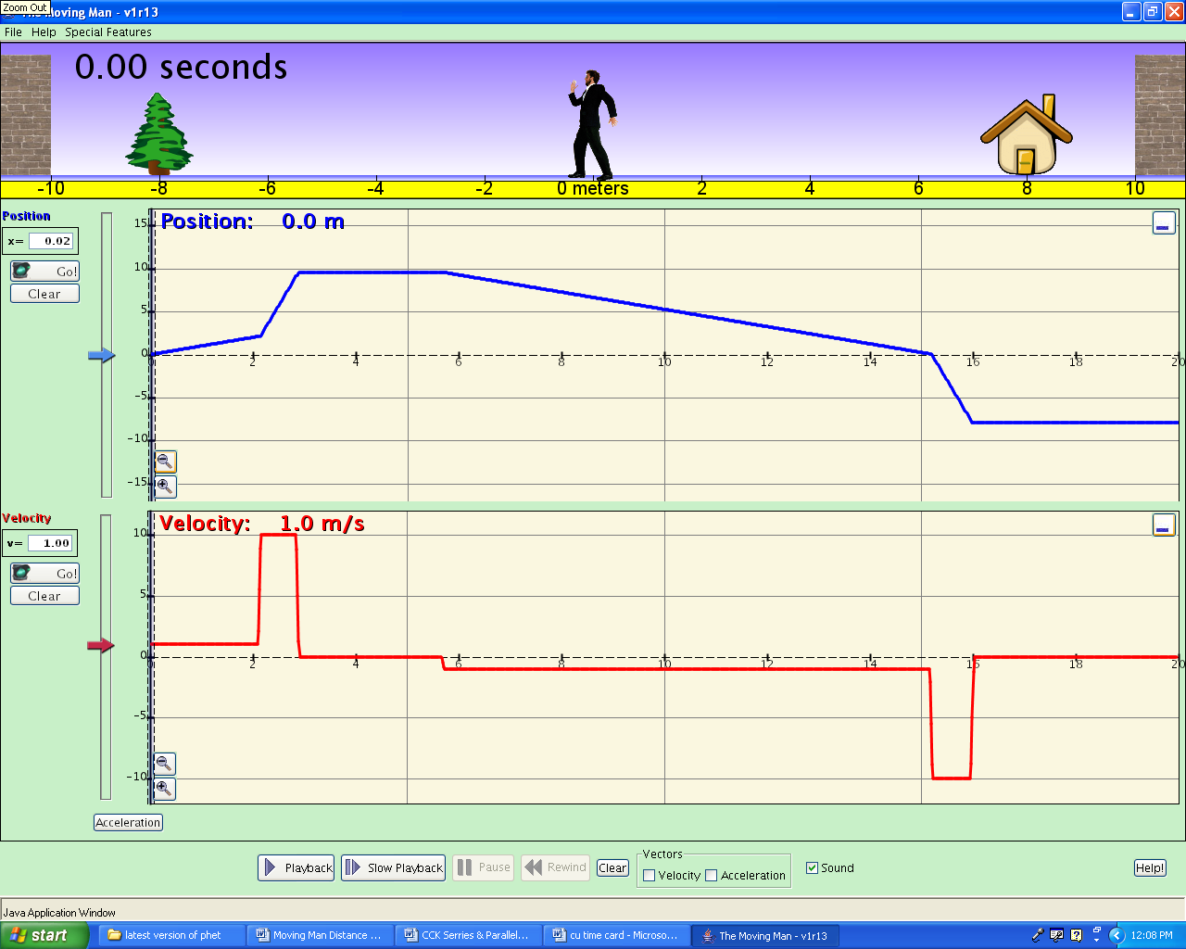
Apply what you learned. Look at the Distance vs. Time graph below and for the different parts of the graph that are marked by the dotted lines make the corresponding Velocity vs. Time graph directly below each part.
-5
-10
5
0
10
Velocity
Time
-5
-10
5
0
10
Velocity
Time
Distance
Time

