Teacher Pages
Prior Knowledge – The students should know:
- How to make a line graph
  - Label axis
  - Plot points and connect with a line
  - The difference between dependent and independent variables
- The basic unit of measure for distance is the meter and they should know approximately how large the meter is.
- a basic understanding of the term “slope of a line”.
Activity & Simulation Instructions-
- This assignment is intended as an assignment the students will complete outside of class either at home or in a library.
- That the 0m point is an arbitrary point and all distance measurements will be made from that point.
- That the positive and negative values represent the direction the man moves from the 0m point.
- To close the velocity and acceleration graphs the students need to click on this symbol, located in the upper right hand corner of the appropriate graph
- That the position graph is a distance vs. time graph
- Give the students a descriptive vocabulary to use in their description of a graph. For example;
Description of | Samples of descriptive phrases
Direction | Moving from ____ to ___ | Moving away from observer | Moving towards observer
Speed | Standing still | Moving slow | Moving fast
Learning Goals – The students will:
- Develop a general knowledge of distance time graphs.
  - What a graph of a person standing still would look like
  - What a graph of a person moving away from an observer would look like.
  - What a graph of a person moving towards an observer would look like.
  - How differences in speed appear on the graph
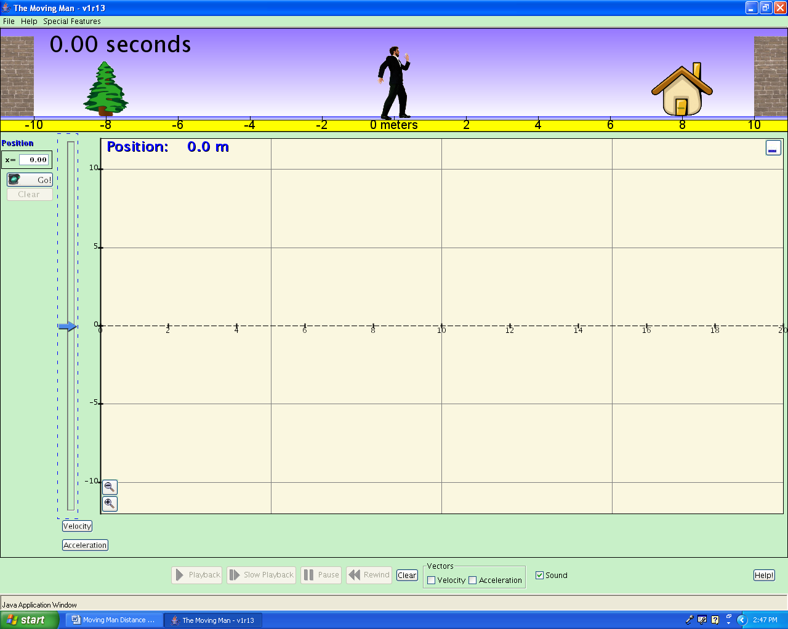
Student Pages
Background – Graphs are not just an evil thing your teacher makes you create, they are a means of communication. In this activity you will learn to speak and read “graph”.
Learning Goals – The students will:
- Develop a general knowledge of distance time graphs.
  - What a graph of a person standing still would look like
  - What a graph of a person moving away from an observer would look like.
  - What a graph of a person moving towards an observer would look like.
  - How differences in speed appear on the graph
Procedure – do the following activity using this web site
Screen 1
http://www.colorado.edu/physics/phet/simulations-base.html
Then click on “The Moving Man”

- Getting started. After “Moving Man” is open leave the position graph open but close all of the other graphs, velocity and acceleration. Your screen should look like screen 1.
- Making observations. By either clicking on the man or the slider cause the man to move back and forth and observe what shows up on the graph. Using the axes provided below make a sketch of the graph that is produced by each action described next to each axis.

A man standing still at 4m.
-5
-10
5
0
10
Time
(s)

Distance (m)
A man moving from 0m to 10m at a fast pace.

-5
-10
5
0
10
Time
(s)

Distance (m)
A man moving from 0m to 10m at a slow steady pace.

-5
-10
5
0
10
Time
(s)

Distance (m)
Apply what you learned. Look at the graph below and for the different parts of the graph that are marked write a statement about what is happening. Be sure to include the direction of motion and the speed of motion.
A man moving from 0m to -10m at a slow steady pace.

-5
-10
5
0
10
Time
(s)

Distance (m)
A man moving from 0m to 5m at a slow steady pace, then moving back to 0m at a slow steady pace.

-5
-10
5
0
10
Time
(s)

Distance (m)
A man moving from 0m to 10m at a slow steady pace, then moving back to 0m at a fast pace.

-5
-10
5
0
10
Time
(s)

Distance (m)
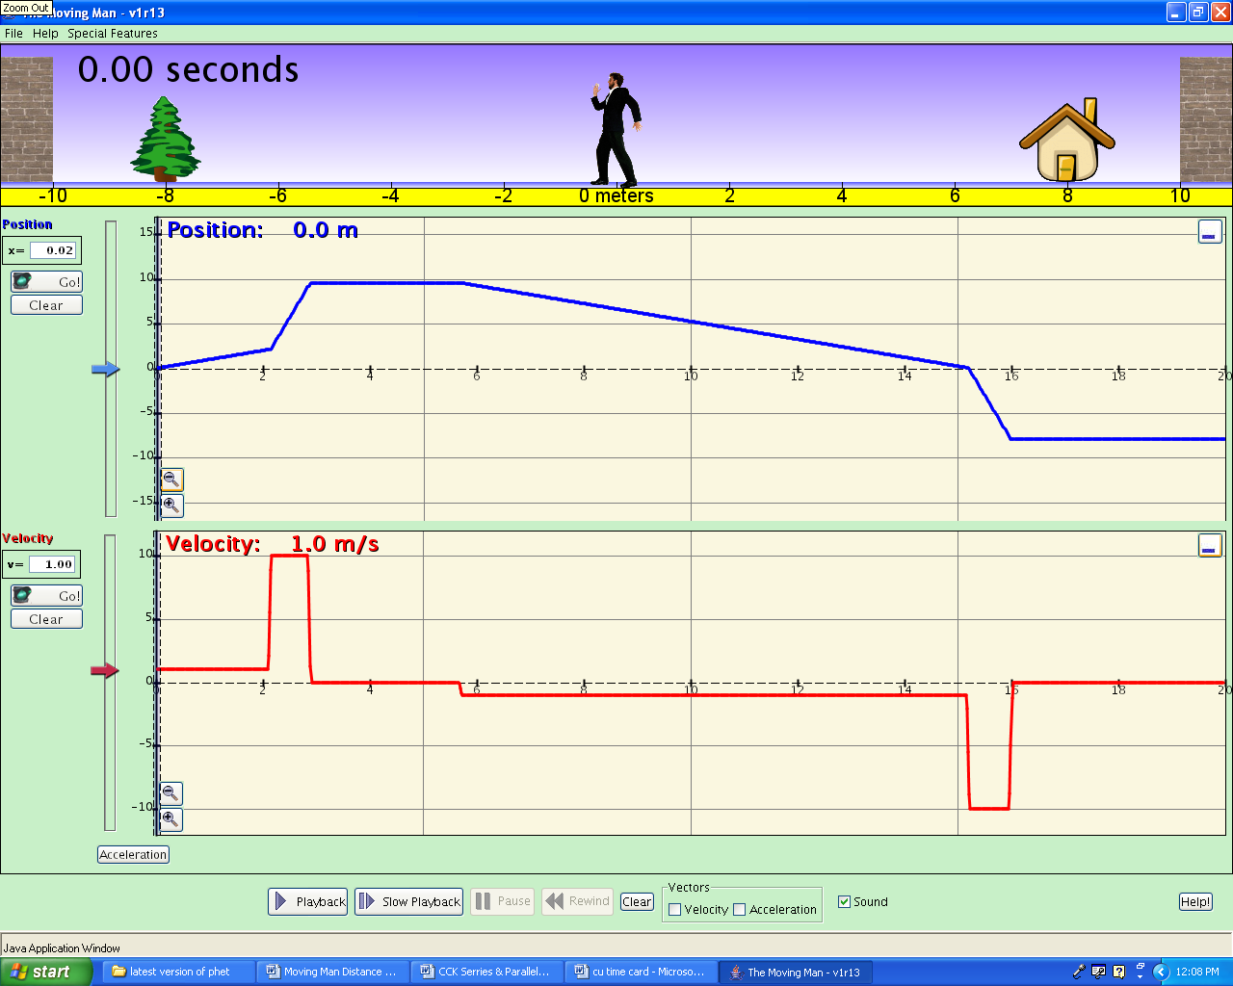
Part A
Part B
Part C
Part D
Part F
Part E

Part | Description of direction and speed

