- A car is traveling along a road. Its acceleration is recorded as a function of time and is shown in the graph below.
accelration
time

Which would be the force-time graph?

A. B. C

force
time
time
time
force
force

2. A cabinet is speeding up as it slides right across the room. Which of the following is a possible free body diagram?

A. B. C.

3. A car is traveling along a road. Its velocity is recorded as a function of time and is shown in the graph below.
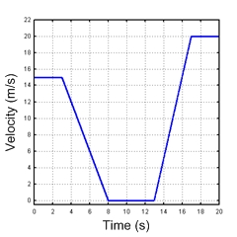
Which would be the force-time graph?
A. B. C

force
force
force

time
time
time
4. A car is moving towards the right and then a force is applied so that the free body diagram looks like.

Which position-time graph best depicts this motion?

