Learning goals: Students will be able to accurately interpret and draw position, velocity and acceleration graphs for common situations and explain their reasoning.

Background: On the first day of class, students use the motion probe to investigate position graphs. That evening, they’ll read in the text an introduction to motion. Position, velocity and acceleration are discussed and graphs are given for some life applications like running a race. On the next days of class, we will use the Moving Man simulation. There are pre/post lab questions written for a handout or there are power point versions suitable for clickers.

Moving Man Introduction:
Go to the PhET site, phet.colorado.edu launch Moving Man from the Simulations front page. Show how to use the sliders to make the man move. Also, demonstrate the playback features.

Lesson: Have the students use the lab sheet for guidance to learn the objective. The activity took my honors physics students about 100 minutes.
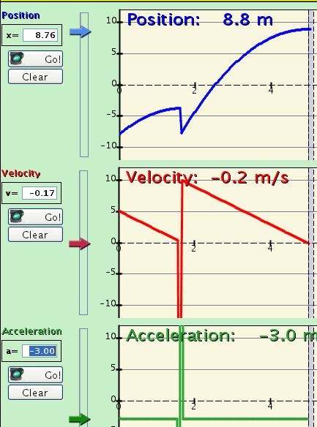
Post lesson: I used the clicker questions some of which were adapted from Perkins’ Homework. Here are directions to use the sim that would help with the Perkins’ questions.
In this example, I set the man at x= -8, v=5, a=-3, pressed Go and Pause when the velocity was 0. Then I set man at –8, v=10, a=-3, pressed Go and Pause when the velocity was 0. I plan to show this with the simulation running, but I made the slide to help me remember settings that work well. When the sim is running, you can move the vertical bar to help interpret approximately how far the man travels to a stop and the times.
For x= -8, v=5, a=-3; distance is about 4 (-4- -8) and the time 1.6s. The time is not on a graph, but is displayed in the man section.
For x= -8, v=10, a=-3; distance is about 16 (8.8- -8) and the time 3.3s ( 5-1.7)
I noticed in my trial that it is difficult to get exact numbers.

